Version: 1.9

Equity Trustees Limited

AFLPA Forecasting & Benefits Calculator

Business Requirements

Document change history

|  |  |  |  |
| --- | --- | --- | --- |
| Version no | Date | Author | Notes |
| 1.1 | 12-Jul-2022 | Apoorva Sreeramakavacham |  |
| 1.2 | 14-Jul-2022 | Apoorva Sreeramakavacham |  |
| 1.3 | 18-Jul-2022 | Apoorva Sreeramakavacham |  |
| 1.4 | 25-Jul-2022 | Apoorva Sreeramakavacham |  |
| 1.5 | 02-Aug-2022 | Apoorva Sreeramakavacham |  |
| 1.6 | 09-Aug-2022 | Maiya Shaforova | Include disclaimers and finalise document |
| 1.7 | 10-Aug-2022 | Apoorva Sreeramakavacham | Usage of single investment rate |
| 1.8 | 25-Aug-2022 | Apoorva Sreeramakavacham | Additional field for contributions |
| 1.9 | 29-Sep-2022 | Apoorva Sreeramakavacham | Periodic payment adjustments |

Document references

|  |  |
| --- | --- |
| document name | version no |
| AFLPA Forecasting & Benefits Calculator Sample |  |
| AFLPA requirements document |  |

Document distribution list

|  |  |  |
| --- | --- | --- |
| NAME | POSITION | DEPARTMENT |
| Peta Assad | Business Analyst | FTO – Technology Services and Projects |
| Rodney Doolan | Manager – Financial Reporting & Fund Accounting | FTO - Finance |
| Steve Najdovski | Client Relationship Manager | TWS |
| Eric Bylsma | General Manager, Business & Client Assurance | TWS |
| Pauline Wong | General Manager, Business Intelligence & Strategy | TWS |
| John Ulkowski | General Manager Business Operations, AFLPA |  |

DOCUMENT APPROVALS

|  |  |  |
| --- | --- | --- |
| NAME | APPROVAL | DATE |
| Rodney Doolan |  | 02-Sep-22 |
| Steve Najdovski |  | 02-Sep-22 |
| John Ulkowski (AFLPA) |  | 02-Sep-22 |
|  |  |  |

Table of Contents

1 Benefits Calculator Input screen 5

2 View results summary 7

2.1 Player details summary 7

2.2 Projection of player’s retirement account 9

2.2.1 Phase 1 Contribution period 9

2.2.2 Phase 2 Post retirement year 11

2.2.3 Phase 3 Periodic payments waiting period 12

2.2.4 Phase 4 Periodic payments period 13

2.2.5 Summary of projections 14

3 Case 1: player with 1- 5 years of service 15

3.1 Projection of player’s Retirement Account 15

3.1.1 Phase 1 Contribution period 15

3.1.2 Phase 2 Post retirement year 16

3.1.3 Phase 3 and 4 - periodic payments waiting & payments periods 17

4 Case 2: player with 6 and 7 Years of service 18

4.1 Projection of player’s Retirement Account 18

4.1.1 Phase 1 Contribution period 18

4.1.2 Phase 2 Post retirement year 19

4.1.3 Phase 3 periodic payments waiting period 20

4.1.4 Phase 4 periodic payments period 20

5 Case 3: player with 8+ years of service 22

5.1 Projection of player’s Retirement Account 22

5.1.1 Phase 1 Contribution period 22

5.1.2 Phase 2 Post retirement year 23

5.1.3 Phase 3 periodic payments waiting period 24

5.1.4 Phase 4 periodic payments period 24

# Benefits Calculator Input screen

Both current players and ex-players should be able to access benefits calculator on the member portal.

When a player selects the benefits calculator from the menu within the portal, the following brief description should be displayed:

**The AFLPA Forecasting Calculator:**

* Illustrates the effect of variable factors such as the length of your playing service with AFL Clubs (as maintained by the AFLPA), contributions and investment returns may have on how much of a final benefit payment you may receive.
* Uses default assumptions about future investment returns and inflation, which are considered reasonable at the current date based on long-term economic modelling (by Mercer Investment Consulting).
* Generates the results in today's dollar value, and due to the effect of inflation will not have the same purchasing power as applies today.

**The Calculator does not take into account:**

* Your personal circumstances;
* Actual future investment returns;
* Inflation;
* Future changes to your player contributions; or
* Future changes to the tax treatment of the final benefit payment.

Before being able to use the calculator, the player will need to acknowledge they had read and accepted the disclaimer via a tick box option, i.e.

*I have read and accepted the important information regarding the use of the calculator contained with the disclaimer*

The ‘important information’ link should open/provide access to the below disclaimer:

**Disclaimer**

This AFLPA Forecasting Calculator has been prepared by Equity Trustees Wealth Services Limited (ABN 33 006 132 332). Any advice contained in this Calculator is of a general nature only; and does not consider the personal needs and circumstances of any particular player. Any final benefit payment to be made to players will be determined following an independent audit where the determination will be final and binding, which may be different to the Calculator illustrations.

The Calculator results do not guarantee the stated investment performance or benefit payout value. Members should expect volatility/variability in investment returns and potential final benefit payout amounts i.e. investment returns and potential benefit payout amounts may be lower than estimated by the Calculator. Investment options with higher expected returns generally have higher variability in returns, including an increased risk of investment losses which may result in lower final benefit payouts.

Prior to acting on any information contained in this Calculator, you need to take into account your own financial circumstances, consider the product disclosure statement for any product you are considering, and seek professional advice from a licensed, or appropriately authorised, financial adviser if you are unsure of what action to take.

To the extent permitted by law, Equity Trustees Wealth Services Limited ABN 33 006 132 332 (ETWSL)  a wholly owned subsidiary of EQT Holdings Limited ABN 22 607 797 615 which is listed on the Australian Securities Exchange (ASX:EQT), their directors, officers, employees and related bodies corporate exclude any liability for any loss, damage (including any consequential loss or damage), claims and expenses (including but not limited to legal costs and defence or settlement costs) suffered or incurred by you directly or indirectly arising out of or in connection with your reliance on the information provided in the calculator or the estimates obtained using the calculator, whether in contract, tort including negligence, statute or otherwise.

This Calculator is not intended as an advertisement for any product issued by EQT Holdings Limited or any of its related entities.  
  
Once, the player acknowledges they had read and accepted the disclaimer, the calculator input screen will be displayed.

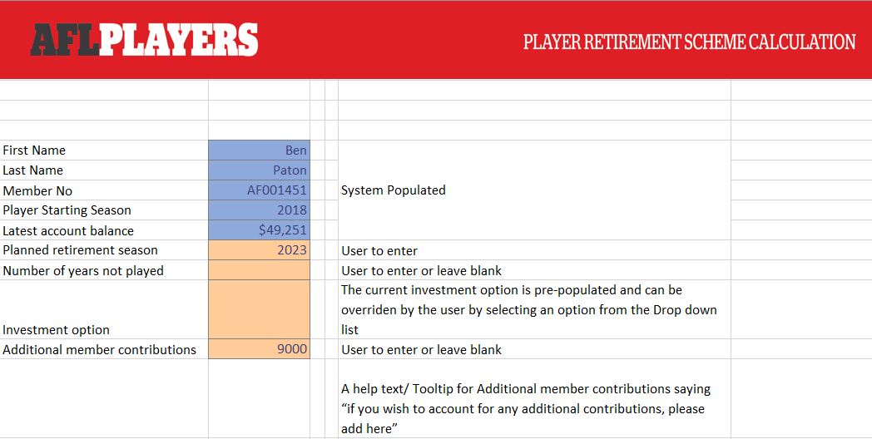

* The input screen takes the required inputs and shows all the calculations in the Results summary screen
* Ensure the following fields are populated by the user (All orange coloured cells in the following Input Screen tab)

# View results summary

Results summary is to be presented as follows:

## Player details summary

This section in the results summary shows the input given by the user and calculations made based on these inputs. A sample summary is as shown:

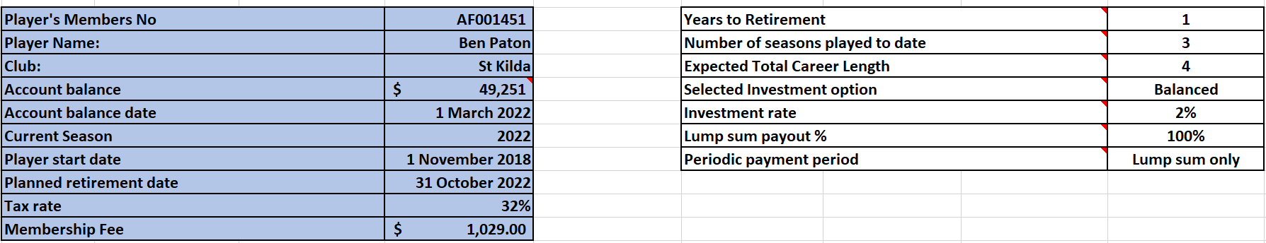

*\* The Tax rate and Membership Fee can change overtime. The Account balance date is the date when the forecasting tool has been run and the account balance includes the additional member contributions give as an input. The Player start date is defaulted to 1st November of the year he starts, and the planned retirement date is defaulted to 31st October of the year of retirement*The calculations are based on the following:

|  |  |
| --- | --- |
| **Value** | **Comments** |
| Years to Retirement | Player: Current year – Year of exit  Ex - Player: Years Retired = Current year – Year of exit |
| Number of seasons played to date | Player: Expected years of service - no. of years not played  Ex - Player: years of service - no. of years not played. |
| Expected Total Career Length | Player: Years to retirement + Number of seasons played to date  Ex – player: Total Career length = Number of seasons played to date |
| Selected Investment option | The investment option chosen by the user in the input screen |
| Investment rate | The appropriate investment is to be displayed (Low/Med/High) |
| Lump sum payout % | 100 % (1-5 years of service) or 30% (more than 5 years of service) |
| Periodic Payment period | 1-5 years – Lump sum only  6,7 years of service – 5years of period payment period  8+ years of service - 10 year of periodic payment period |

Following are the different investment options and rates:

|  |  |
| --- | --- |
| **Investment option** | **Investment rate** |
| Balanced | 2% |
| Conservative | 1% |
| Growth | 3% |
| High growth | 4% |

*\*The investment rates are subject to change*

## Projection of player’s retirement account

The projection of Player’s retirement account depends on the status of the player i.e. (player or Ex-player). All the four phases are shown to the current player whereas for the Ex-player, current and future phases are shown.

### Phase 1 Contribution period

During this phase the Annual contributions are made until the year of retirement. The AFLPA Investment contribution amounts are determined based on a member years of service with quarterly instalments received in February (25%) and May (25%) with the two remaining quarterly instalments (50%) received in August as follows:

|  |  |
| --- | --- |
| **Years Played** | **FY2022 Annual Contribution** |
| 1 | $10,560 |
| 2 | $12,672 |
| 3 | $14,784 |
| 4 | $14,784 |
| 5 | $15,840 |
| 6 | $16,896 |
| 7 | $17,952 |
| 8 | $19,008 |
| 9 | $20,064 |
| 10+ | $21,120 |

*\*Based on the month of account balance, the contributions are shown accordingly in the projections, (i.e. if the Account balance is at 1st March 2022, the contributions and investment returns from may are shown (i.e. the next quarter), a sample contribution is as follows:*



|  |  |
| --- | --- |
| **Field** | **Formula** |
| Investment rate | Selected investment option |
| Annual contribution amount | The amount depends on the player’s years of service – Refer to the table in 2.2.1 |
| Opening Bal 1 November | Account balance at 1 November |
| Investment return to Mid Feb | ((Account balance * Investment rate) / no. of days in the year) * no. of days from the date of Account balance to mid Feb |
| Contribution % | Annual Contribution amount * percentage (25% or 50%) |
| Balance at Mid of Feb | Opening Bal 1Nov + Investment return to mid Feb + Contribution 25% |
| Investment return to Mid-May | ((Balance at mid of Feb * Investment rate) / no. of days in the year) *no. of days mid-Feb to mid-May |
| Balance at Mid of May | Balance at mid of Feb +Investment return to mid may+ Contribution 25% |
| Investment return to Mid-August | ((Balance at mid of May * Investment rate) / no. of days in the year) * no. of days mid-May to mid-Aug |
| Balance at Mid of Aug | Bal at Mid may + Investment return at mid Aug + Contribution 50% |
| Investment return to 31st October | ((Balance at mid of Aug * Investment rate) / no. of days in the year) * no. of days mid-Aug to 31st October |
| Closing Bal 31 October | Bal at mid Aug + Investment return to 31Oct |

*\* No auto switches of the investment rates, Telstra and any other contribution are considered for the next sections of this sample. 14th day is considered as Mid of any month in the sample projections. The Account balance includes the additional member contributions give as an input.* A sample Contribution period summary is as shown:

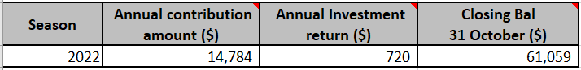

|  |  |
| --- | --- |
| **Field** | **Formula** |
| The Annual investment return | Sum of all the investment returns (Investment return to Mid Feb + Investment return to Mid-May + Investment return to Mid Aug + Investment return to 31 October) |
| Closing Bal 31 October | Bal at mid Aug + Investment return to 31st Oct (Derived from the calculations in the table above) |

### Phase 2 Post retirement year

One year after the retirement, the investment return on member balance, Total Member balance after investment, Lump sum amount, Lump sum payout after fees and tax are calculated as follows:

|  |  |
| --- | --- |
| **Field** | **Formula** |
| Opening member Balance | Closing balance of Phase 1 |
| Investment return on Member Balance | Opening member balance * Selected Investment rate  adjusted till 30th June |
| Total member balance after Inv. Return | Opening member balance + Investment return on Member Balance |
| Lump Sum Amount Gross | Total member balance after Inv. Return* Lump sum payout % |
| Lump Sum Payout After Fees & Tax | (Lump Sum Amount Gross) – ((Lump Sum Amount Gross) *Tax rate) - Membership Fee |
| Closing balance | Total member balance after investment - Lump Sum Amount Gross |

**Note:**

* + The investment return rates and lump sum payout % are as in 2.1
  + The Tax rate on lump sum payment and Player Membership Fee can change overtime.
  + At the time the forecast is being completed, pro rata interest calculations will be performed to come to 30th June of the year - post retirement.

### Phase 3 Periodic payments waiting period

After the post retirement year, there is a periodic payment waiting period of 3 years for the players with total years of service greater than 5. During this time, interest is compounded and calculated based on the investment option applicable (Refer to section 2.1 ). A sample periodic payment waiting period and the formulas are as follows:

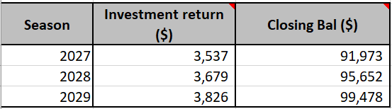

|  |  |
| --- | --- |
| **Field** | **Formula** |
| Investment return | For year 1: Closing balance (phase 2) * Investment rate (selected by the user)  For year 2&3: Closing balance of previous year * Investment rate (selected by the user) |
| Closing balance | For year 1: Opening balance (Phase 2) + Investment return (year 1)  For year 2&3: Closing balance of previous year + Investment return (year 1) |

### Phase 4 Periodic payments period

During this phase the periodic payments are done based on the member’s years of service (Refer to section 2.1). Sample periodic payments for 6,7 years of service (5 years of periodic payment) and 8+ years (10 years of periodic payment) are as shown:

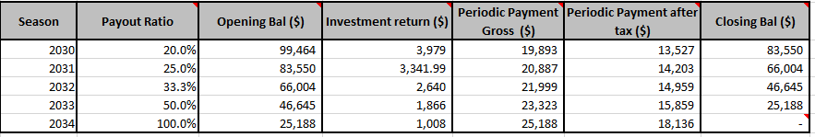

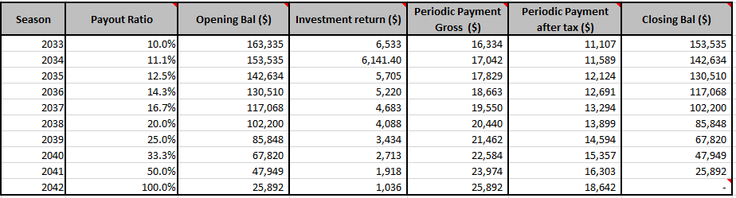

|  |  |
| --- | --- |
| **Field** | **Formula** |
| Payout Ratio | **6,7 years of service**: 20.0%, 25.0%, 33.3%, 50.0%, 100%  **8+ years of service:** 10.0%,11.1%, 12.5%, 14.3%, 16.7%, 20.0%, 25.0%, 33.3%, 50%, 100.0%  *The payout ratio is calculated as [100% / no. of years left till last payment]  These values are defaulted with respect to the years of service. |
| Opening balance | For year 1: Closing balance (Phase 3), later: Closing balance of previous year |
| Investment return | For year 1: Closing Bal (phase 2) * Investment rate (selected by the user)  For year 2&3: Closing Bal of previous year * Investment rate (selected by the user) |
| Periodic payment Gross | Opening Bal* payout ratio |
| Periodic Payment After tax | Periodic payment Gross * Tax rate |
| Closing balance | Opening Bal + Investment return – Periodic Payment Gross |

*\*The Investment return for the last year is included in the periodic payment and the account balance will be zero.*

### Summary of projections

Sample summary of the projections is as below:

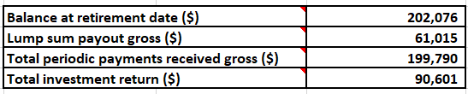

|  |  |
| --- | --- |
| **Field** | **Formula** |
| Balance at retirement date | Balance after the last contribution (Closing balance of Phase 1) |
| Lump sum payout gross | opening member balance * Lumpsum payout% |
| Total periodic payment received gross | Total of Periodic payments gross |
| Total Investment return | Investment return (Phase 1 + Phase 2 + Phase 3 + Phase 4) |

# Case 1: player with 1- 5 years of service

Consider the following player with 4 years of service by the time of retirement with a Balanced investment option chosen. The following tables show the user input and the calculations from the input.

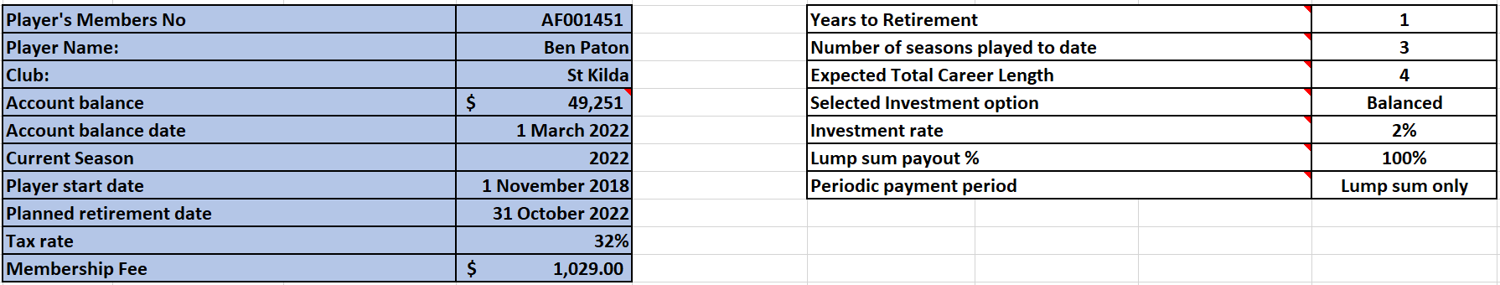

## Projection of player’s Retirement Account

### Phase 1 Contribution period

Annual contributions are made until the year of retirement i.e. end of 2022 in this case, and the closing balance after the last contribution made is taken as the opening member balance for the Phase 2 Post retirement year. The Annual contributions and the investment returns (chosen by the user - (*Investment option as Balanced – 2%)) are as shown:



The investment return and Contributions from Mid-May are considered in this case as the account balance date is 1st March 2022 and the next contribution is in May. The account balance = 9000 + 40,251 (Includes additional member contributions). Refer 2.2.1 for the Annual contribution amounts with respect to the years of service)

The calculations are as shown:

|  |  |
| --- | --- |
| **Field** | **Formula** |
| Investment return to Mid-May | = ((49,251*0.02)/365) *75 = 202 |
| Contribution 25% | = 14,784*0.25 = 3,696 |
| Balance at Mid of May | =49,251+202+369 = 53,149 |
| Investment return to Mid-August | = ((53,149*0.02)/365) *92 = 268 |
| Contribution 50% | =14,784*0.5 = 7,392 |
| Balance at Mid of Aug | =52,149+268+7,392 =60,809 |
| Investment return to 31 October | = ((60,809*0.02)/ 365) *75 |
| Closing Bal 31st October | = 60,809 + 250 = **61,059** |

The summary is as shown:

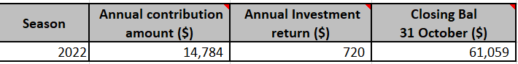

*\*Annual investment return = sum of all the investment return over the contribution period*

### Phase 2 Post retirement year

During the post retirement year, based on the Opening member Balance (Closing balance of Phase 1) of the player’s retirement account, after the investment returns, Lump Sum pay out after Fees and Tax the closing balance is calculated as below. (Refer 2.2.2 for rules and formulas)

The following calculations are based on the investment option set as **Balanced,** opening member balance = 61,059, Tax = 32%, Lump sum payout = 100%, Membership fee = 1029, with Investment rate = 2% (The inputs are as specified above)

|  |  |
| --- | --- |
| **Field - Formula** | **value** |
| Investment return on Member balance = (Opening member balance * selected Investment rate))/365) *242  adjusted till 30th June | ((61,059*0.02)/12) *8 = 810 |
| Total member balance after investment return = Opening member balance + Investment return on Member balance | 61,059 + 810 = 61,869 |
| Lump Sum Amount Gross = Total member balance after investment return* Lump sum payout % | 61,869*1= 61,869 |
| Lump Sum Payout After Fees & Tax = (Lump Sum Amount Gross) – ((Lump Sum Amount Gross) *Tax rate) - Membership Fee | 61,869 – (61,869*0.32) - 1029 = 41,042 |
| Closing balance = Total member balance after investment return - Lump Sum Amount Gross | = 0 |

### Phase 3 and 4 - periodic payments waiting & payments periods

The players with 1- 5 years of service do not have any waiting period and the periodic payments period and hence the lump sum payout of 100% is done during the post retirement year (phase 2) and the account is closed.

Totals projected from latest account balance date to final payment:

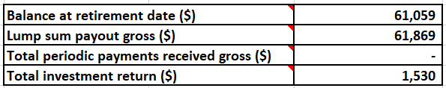

# Case 2: player with 6 and 7 Years of service

Consider the following player with 7 years of service by the time of retirement with a Balanced investment option chosen. The following tables show the user input and the calculations from the input.

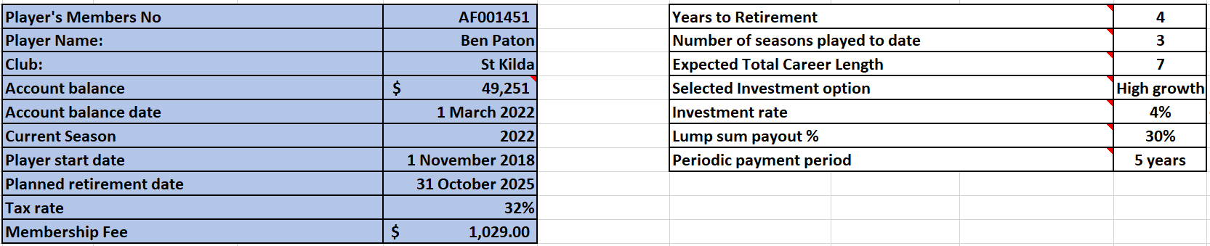

## Projection of player’s Retirement Account

### Phase 1 Contribution period

The Annual contributions are made from the current year to the year of retirement, i.e. from 2022 to 2025 for this case. The contributions are shown based on the account balance date and the Investment option chosen by the user. The account balance = 9000 + 40,251 (Includes additional member contributions). (Refer to the example and rules in 2.2.1 & 6.1.1).

The contributions are as shown:



The Summary of contribution period is as follows:

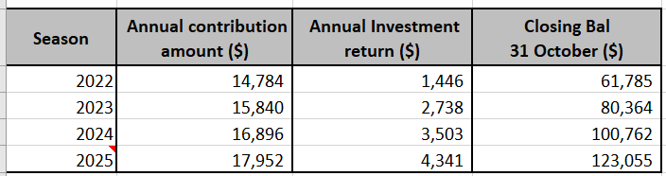

*\*Calculated from 2022 - 2025 in the same way as Case 1-5 years of service (Refer 4.1.1)*

### Phase 2 Post retirement year

During the post retirement year, based on the Opening member Balance (Closing balance of Phase 1) of the player’s retirement account, after the investment returns, Lump Sum pay out after Fees and Tax the closing balance is calculated as below.

The following calculations are based on the investment option set as **High growth (4%),** Opening member balance = 123,055 , Tax = 32%, Lump sum payout = 30%, Membership fee = 1029, with Investment rate =4% (The inputs are as specified above)

|  |  |
| --- | --- |
| **Field** | **Formula** |
| Investment return on Member balance = (Opening member balance * selected Investment rate))/365) *no. of days until 30th June | = (123,055*0.04/365) *242) = 3,263 |
| Total member balance after investment return = Opening member balance + Investment return on Member balance | = 123,055 + 3,263 = 126,319 |
| Lump Sum Amount Gross = Total member balance after investment return* Lump sum payout % | = 126,319 * 0.3 = 37,896 |
| Lump Sum Payout After Fees & Tax = (Lump Sum Amount Gross) – ((Lump Sum Amount Gross) *Tax rate) - Membership Fee | = 37,896-(37,896*0.32) -1029= 37,896 |
| Closing balance = Total member balance after investment return - Lump Sum Amount Gross | = 123,055 - 37,896 = 88,423 |

The summary of Post retirement period is as follows:



### Phase 3 periodic payments waiting period

The players with 6 or 7 Years of service have a waiting period of 3 years. Where the Investment continues with a rate of 4% (High growth), the balance over the next 3 years after the Phase 2 is as follows:

|  |  |  |
| --- | --- | --- |
| **Season** | **Investment return ($)** | **Closing Bal ($)** |
| 2027 | 3,537 | 91,960 |
| 2028 | 3,678 | 95,638 |
| 2029 | 3,826 | 99,464 |
| Total investment return = $ 11,041 | | |

\**Closing balance from the Phase 2 is taken as the opening balance for phase 3, refer 2.2.3 for rules and formulas*

### Phase 4 periodic payments period

The players with 6 or 7 years of service will get a periodic payment for 5years as follows:

|  |  |  |  |  |  |  |
| --- | --- | --- | --- | --- | --- | --- |
| **Season** | **Payout Ratio** | **Opening Bal** | **Investment return** | **Periodic Payment Gross** | **Periodic Payment after tax** | **Closing Bal** |
|  |  |  | **= Opening Bal * 0.04** | **= Opening Bal *Investment return** | **= Periodic Payment Gross – Periodic Payment Gross * Tax rate** | **= Opening Bal + Investment**  **return – Periodic payment** |
| 2030 | 20.0% | 99,464 | 3,979 | 19,893 | 13,527 | 83,550 |
| 2031 | 25.0% | 83,550 | 3,341.99 | 20,887 | 14,203 | 66,004 |
| 2032 | 33.3% | 66,004 | 2,640 | 21,999 | 14,959 | 46,645 |
| 2033 | 50.0% | 46,645 | 1,866 | 23,323 | 15,859 | 25,188 |
| 2034 | 100.0% | 25,188 | 1,008 | 25,188 | 18,136 | - |

*\*Closing balance of Phase 3 = Opening balance of Phase 4, refer 2.2.4 for rules and formulas*

*\*The Investment return for the last year is included in the periodic payment and the account balance will be zero.*

Totals projected from latest account balance date to final payment:

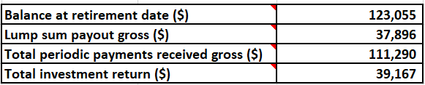

# Case 3: player with 8+ years of service

Consider the following player with 10 years of service by the time of retirement with a Balanced investment option chosen. The following tables show the user input and the calculations from the input

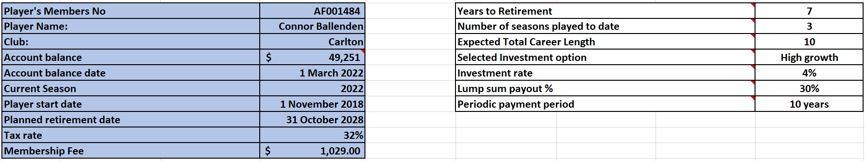

## Projection of player’s Retirement Account

### Phase 1 Contribution period

The Annual contributions are made from the current year to the year of retirement, i.e. from 2022 to 2028 for this case. The contributions are shown based on the account balance date. The account balance = 9000 + 40,251 (Includes additional member contributions) (Refer to the example and rules in 2.2.1 & 6.1.1). The contributions are as shown:

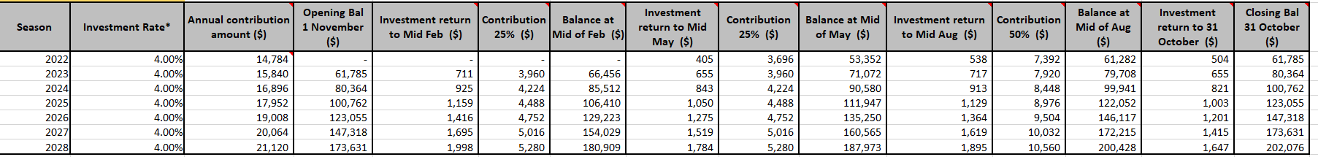

The summary of contribution period is as follows:

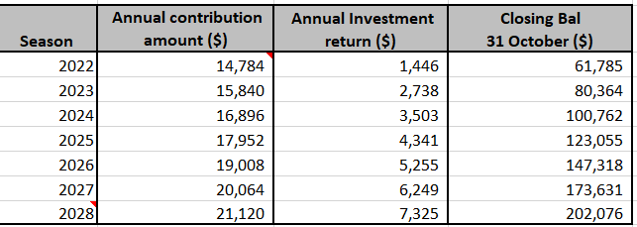

*\*Calculated from 2022 - 2028 in the same way as Case 1-5 years of service (Refer 4.1.1)*

### Phase 2 Post retirement year

During the post retirement year, based on the Opening member Balance (Closing balance of Phase 1) of the player’s retirement account, after the investment returns, Lump Sum pay out after Fees and Tax the closing balance is calculated as below.

The following calculations are based on the investment option set as **High growth,** opening member balance = 202,076, Tax = 32%, Lump sum payout = 30%, Membership fee = 1029, with Investment rate = 4% (The inputs are as specified above)

|  |  |
| --- | --- |
| **Field** | **Formula** |
| Investment return on Member balance = (Opening member balance * selected Investment rate))/365) *no. of days until 30th June | = ((202,076*0.04)/365) *242 = 5,359 |
| Total member balance after investment return = Opening member balance + Investment return on Member balance | = 202,076 + 5,359= 207,435 |
| Lump Sum Amount Gross = Total member balance after investment return* Lump sum payout % | = 207,435*0.3 = 62,230.45 |
| Lump Sum Payout After Fees & Tax = (Lump Sum Amount Gross) – ((Lump Sum Amount Gross) *Tax rate) - Membership Fee | =62,230.45– (62,230.45*0.32)-1029  = 41,288 |
| Closing balance = Total member balance after investment return - Lump Sum Amount Gross | = 207,435 - 62,230.45 =145,204 |

*Refer 2.2.2 for rules and formulas  
The summary of Post retirement period is as follows:



### Phase 3 periodic payments waiting period

The players with 8+ years of service have a waiting period of 3 years. Where the Investment continues with a rate of 4% (High growth), the balance over the next 3 years after the Phase 2 is as follows:

|  |  |  |
| --- | --- | --- |
| **Season** | **Investment return ($)** | **Closing Bal ($)** |
| 2030 | 5,808 | 151,013 |
| 2031 | 6,041 | 157,053 |
| 2032 | 6,282 | 163,335 |
| Total investment return = $ 18,131 | | |

\**Closing balance from the Phase 2 is taken as the opening balance for phase 3. Refer 2.2.3 for rules and formulas*

### Phase 4 periodic payments period

The players with 8+ years of service will get a periodic payment for 10 years as follows:

|  |  |  |  |  |  |  |
| --- | --- | --- | --- | --- | --- | --- |
| **Season** | **Payout Ratio** | **Opening**  **Bal** | **Investment return**  **(4%)** | **Periodic Payment** | **Periodic Payment after tax** | **Closing Bal** |
|  |  |  | **= Opening Bal * 0.04** | **= Opening Bal *ratio** | **= Periodic Payment Gross – Periodic Payment Gross * Tax rate** | **=Opening Bal + Investment return – Periodic payment** |
| 2033 | 10.0% | 163,335 | 6,533 | 16,334 | 11,107 | 153,535 |
| 2034 | 11.1% | 153,535 | 6,141.40 | 17,042 | 11,589 | 142,634 |
| 2035 | 12.5% | 142,634 | 5,705 | 17,829 | 12,124 | 130,510 |
| 2036 | 14.3% | 130,510 | 5,220 | 18,663 | 12,691 | 117,068 |
| 2037 | 16.7% | 117,068 | 4,683 | 19,550 | 13,294 | 102,200 |
| 2038 | 20.0% | 102,200 | 4,088 | 20,440 | 13,899 | 85,848 |
| 2039 | 25.0% | 85,848 | 3,434 | 21,462 | 14,594 | 67,820 |
| 2040 | 33.3% | 67,820 | 2,713 | 22,584 | 15,357 | 47,949 |
| 2041 | 50.0% | 47,949 | 1,918 | 23,974 | 16,303 | 25,892 |
| 2042 | 100.0% | 25,892 | 1,036 | 25,892 | 18,642 | - |

*\*The Investment return for the last year is included in the periodic payment and the account balance will be zero.*

Totals projected from latest account balance date to final payment:

